A Minor Project Report

**Educational Platform for Learning IoT**

**BACHELOR OF TECHNOLOGY**

**IN**

**COMPUTER SCIENCE ENGINEERING - IOT**

SUBMITTED BY

Ayush Sharma(22)

Jatin Kumar(38)

Sachin Rawat(67)

**(GROUP NO : 23)**

Under the Supervision of

**Ms. Neha Katiyar**

Assistant Professor

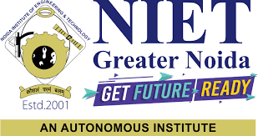

May 2023

**DEPARTMENT OF CSE-IOT**

SCHOOL OF CSE EMERGING TECHNOLOGIES, NIET, GREATER NOIDA

**CERTIFICATE**

This is to certify that the project report entitled Educational Platform for Learning IoT submitted by Ayush Sharma, Jatin Kumar, Sachin Rawat **t**o the Department of Computer Engineering, Internet of Things, NIET as a minor project report for **B.Tech in (Computer Engineering-IOT)** is a *bona fide* record of project work carried out by Ms Neha Katiyar under my supervision. The contents of this report, in full or in parts, have not been submitted to any other Institution or University for the award of any degree.

May 2023 Ms Neha Katiyar

Greater Noida (Assistant Professor)

Department of Computer Engineering (IOT)

Counter signature of HOD with seal

**DECLARATION**

I declare that this project report titled **Educational Platform for Learning IoT** submitted as minor project report for **B. Tech in (Computer Engineering-IOT)** is a record of original work carried out by me under the supervision of Ms. Neha Katiyar, and has not formed the basis for the award of any other degree, in this or any other Institution or University. In keeping with the ethical practice in reporting scientific information, due acknowledgements have been made wherever the findings of others have been cited.

Greater Noida- STUDENT NAMES:

May,2023 Ayush Sharma

Jatin Kumar

Sachin Rawat

**ACKNOWLEDGMENTS**

This project consumed huge amount of work, research and dedication. Its implementation would not have been possible if, I did not have a support of many individuals. Therefore, I would like to extend our sincere gratitude to all of them. First of all, I am thankful to our supervisor **Ms.Neha Katiyar** for providing necessary guidance concerning projects implementation.

I place on record, my profound sense of gratitude to **Mr. Mayank Deep Khare**, professor & head, department of computer engineering (IOT) to give me an opportunity to enhance my technical skills and valuable suggestions in this project.

I also want to thank to all who directly or indirectly, have lent their helping hand in this project.

Last but not the least, I would like to thank my classmates, **Mr. Aniket Kumar Gupta** I would like to thank my seniors **Mr. Avadhesh Chandra Tewari** for supporting me in resolving personal as well as technical issues throughout the semester.

I would like to express my sincere thanks towards volunteer researchers who devoted their time and knowledge in the implementation of this project.

STUDENTS NAMES:

AYUSH SHARMA

JATIN KUMAR

SACHIN RAWAT

**ABSTRACT**

This project aims to provide an educational website that offers comprehensive and accessible information about the Internet of Things (IoT) and its applications. Currently, learners have to rely on multiple sources and search engines to find the information they need, as there is no centralized platform for learning about IoT. The website includes interactive components such as simulations and projects to facilitate user engagement and learning. It is designed and developed using open-source web development technologies, such as HTML, CSS, JavaScript and Node.js informed by both quantitative and qualitative methods to assess its effectiveness in improving users' knowledge and understanding of the IoT. Additionally, the website features a user-friendly interface and a search function that enables users to quickly find the information they require. Overall, this project provides a valuable resource for learners seeking to acquire knowledge about the IoT from a centralized and accessible platform. It aims to enhance users' understanding of the IoT and increase their interest in the topic, addressing the current lack of a centralized platform for learning about this emerging technology.

**Keywords –** Internet of Things (IoT), Educational website, Comprehensive information, Interactive components, Open-source web development.

**1.INTRODUCTION**

The Internet of Things (IoT) is a rapidly emerging technology that is changing the way we interact with our world. As the number of IoT devices continues to grow, it has become increasingly important for individuals to understand the implications and potential applications of this technology. However, learners seeking to acquire knowledge about the IoT are often faced with the challenge of navigating multiple sources of information, leading to a lack of centralized and comprehensive resources for learning. To address this issue, we have developed a website for learning about the IoT that provides a centralized and accessible platform for acquiring knowledge about this emerging technology.

Our website aims to provide comprehensive and accessible information about the IoT, including its history, current trends, and future directions. It includes interactive components such as simulations and quizzes to facilitate user engagement and learning. The website is designed and developed using open-source web development technologies, such as HTML, CSS, and JavaScript, to ensure that it is both user-friendly and accessible to a broad range of learners.[6]

In addition to providing comprehensive information about the IoT, our website also features a user-friendly interface and a search function that enables users to quickly find the information they require. The website is informed by both quantitative and qualitative methods to assess its effectiveness in improving users' knowledge and understanding of the IoT. The site is intended to be a valuable resource for learners seeking to acquire knowledge about the IoT from a centralized and accessible platform.

Overall, our project aims to address the current lack of centralized and comprehensive resources for learning about the IoT. By providing a website that offers comprehensive information, interactive components, and a user-friendly interface, we hope to enhance users' understanding of the IoT and increase their interest in the topic. Our project represents a valuable resource for learners seeking to acquire knowledge about the IoT and serves as a foundation for future research and development in this area.[7]

**2.PROBLEM STATEMENT**

The problem that this project aims to address is the lack of a centralized platform for learning about the Internet of Things (IoT). Currently, learners interested in acquiring knowledge about the IoT have to rely on multiple websites and search engines to gather information. This can be time-consuming and overwhelming, as the information available may be fragmented, incomplete, or inconsistent. Moreover, learners may struggle to find reliable sources and may not have the necessary expertise to evaluate the quality of the information they find. This fragmented approach to learning can hinder the acquisition of a comprehensive understanding of the IoT and limit the potential for its application. Thus, the need for a centralized platform for learning about the IoT is essential, providing learners with comprehensive, reliable, and accessible information on this emerging technology. [10]This project seeks to fill this gap by providing an educational website that offers comprehensive and accessible information about the IoT and its applications. It will include interactive components to facilitate user engagement and learning, and a user-friendly interface that enables learners to quickly find the information they require. Overall, this project aims to enhance users' understanding of the IoT and increase their interest in the topic by addressing the lack of a centralized platform for learning about this technology.

**3.METHODOLOGY**

To begin with, the first step involved conducting research and analyzing existing resources on IoT to identify the gaps in the current available information and resources. Our research revealed that while there are several resources available online for learning about IoT, there is no centralized platform that provides comprehensive information in one place. Learners often have to rely on multiple websites and search engines to gather information on different aspects of IoT, which can be time-consuming and challenging.

To address this issue, we decided to create a website that would serve as a one-stop-shop for learners to access all the information related to IoT. For building the website, we opted to use open-source web development technologies such as HTML, CSS, and JavaScript, which provided us with flexibility and control over the design and functionality of the website.[5]

We utilized Visual Studio Code (VSCode) as the primary Integrated Development Environment (IDE) for creating the website. VSCode offered a wide range of features such as code highlighting, debugging tools, and extensions, which made the development process more efficient and streamlined.

To test and debug the website, we used Google Chrome and Mozilla Firefox browsers, which allowed us to identify and resolve any compatibility issues that arose during the development process.

One of the key features of the website was the incorporation of interactive components such as simulations and quizzes using JavaScript. These interactive elements helped to enhance user engagement and facilitate learning by providing a more hands-on and interactive learning experience.

Additionally, we utilized Node.js to develop the back-end functionalities of the website, including search functionality and user authentication. Node.js allowed us to create a scalable and efficient web application with minimal overhead and easy integration with other web services.

We also employed both quantitative and qualitative methods to evaluate the effectiveness of the website in improving users' knowledge and understanding of the IoT. This included collecting and analyzing data on user engagement, learning outcomes, and user satisfaction through user surveys and website usage analytics.[2]

In conclusion, the methodology used for creating the website for learning IoT involved a thorough analysis of existing resources, the use of open-source web development technologies, incorporation of interactive components, and the evaluation of the website's effectiveness using both quantitative and qualitative methods. The result was an effective and user-friendly website that provided comprehensive information on IoT and addressed the need for a centralized platform for accessing information.[11]

Fig 3.1

**4.IMPLEMENTATION AND WORKING**

4.1 Technology stack: The project was developed using various web development technologies like HTML, CSS, and JavaScript for creating the frontend of the website. For the backend, we used Node.js which is a server-side JavaScript runtime environment. We also used Chrome and Firefox browsers for testing the website and Visual Studio Code as the code editor.

4.2 Website Design: We focused on creating a user-friendly design for the website that would make it easy for learners to navigate and find the information they need. We used HTML and CSS to create the layout and styling of the website, and JavaScript to add interactivity and functionality.

4.3 Content Creation: We researched and compiled information related to IoT from various sources to ensure that our website provides comprehensive and accurate information on the topic. We used our knowledge of the subject matter to organize the information into different sections and create engaging content that would keep the learners interested.

4.4 Interactive Components: To make the learning experience more engaging, we incorporated interactive components like quizzes, simulations, and exercises into the website. We used JavaScript to create these interactive components to enhance the user experience.

4.5 Backend Implementation: To ensure that the website functions smoothly and efficiently, we used Node.js for the backend implementation. We created a server using Node.js that would handle user requests, retrieve data from the database, and send the response back to the user

Overall, our project involved extensive research, design, and implementation using a range of web development technologies and tools. By creating a comprehensive website for learning about IoT, we aimed to provide an accessible and user-friendly platform for learners to access all the information they need without having to rely on multiple websites and search engines.

Fig 4.1

4.6 **Working Project**

Fig 4.6.1

Fig 4.6.2

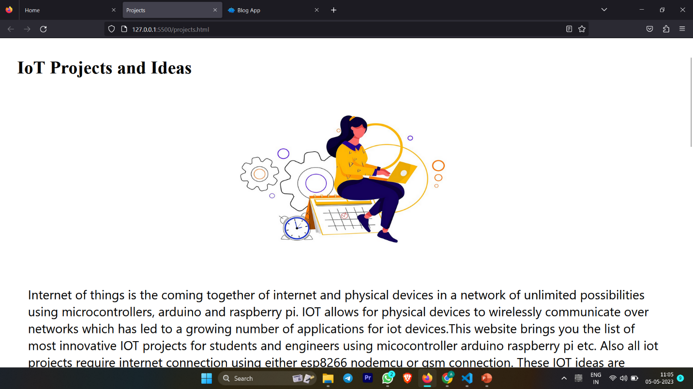Fig 4.6.3

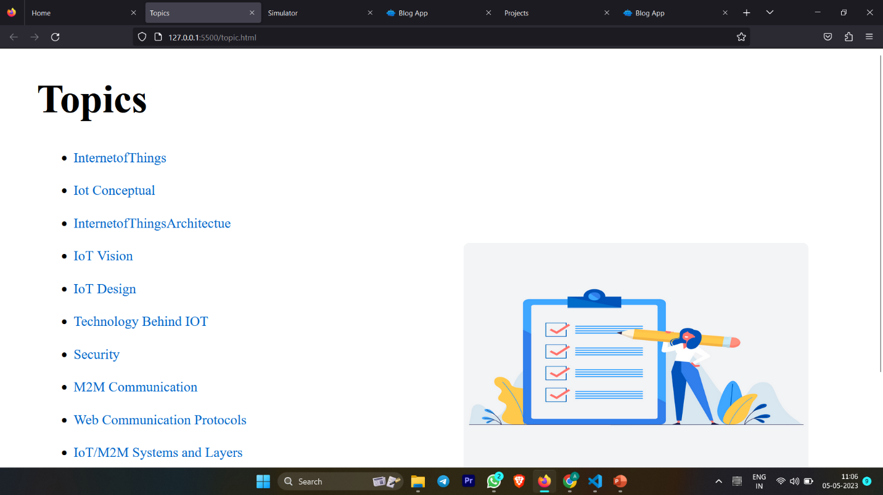

Fig 4.6.4

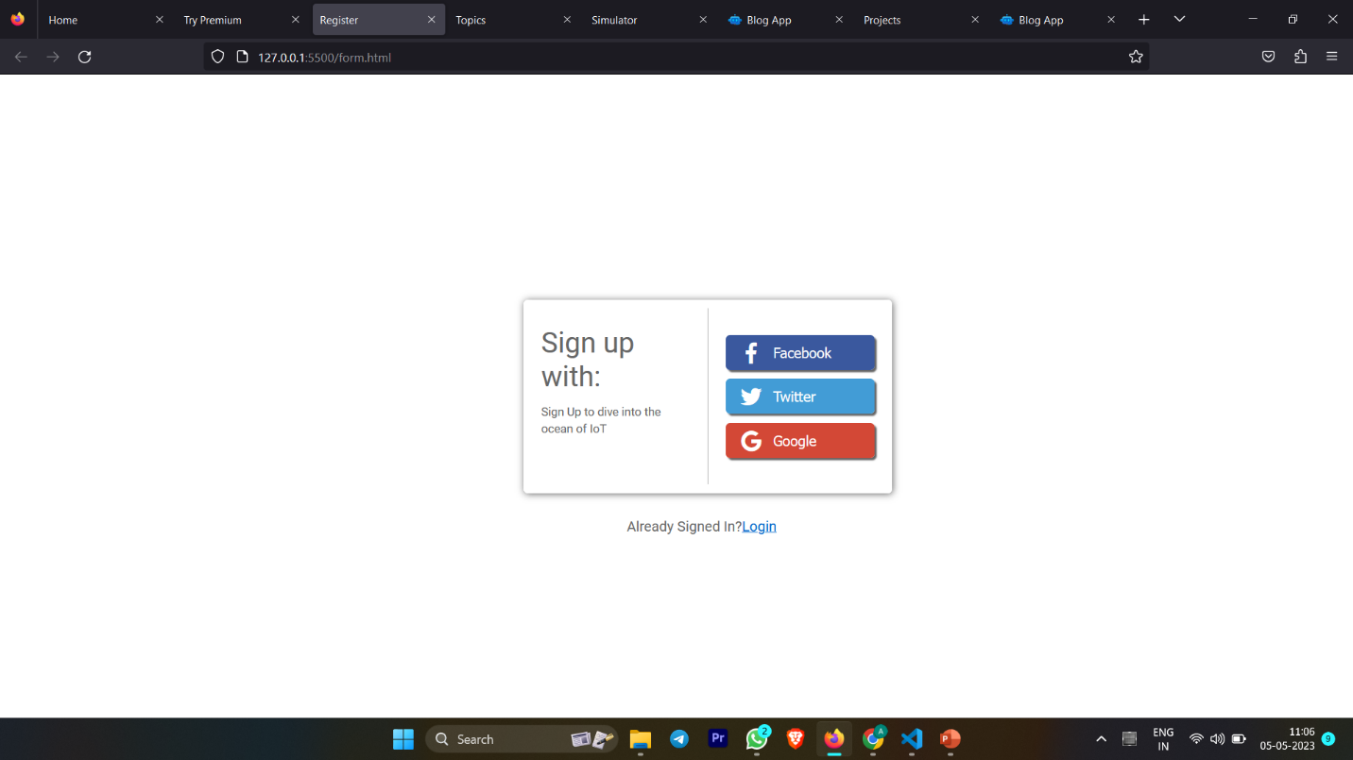

Fig 4.6.5

**4.6.2 Server side code :**

import express from 'express';

import *as dotenv from 'dotenv';

import cors from 'cors';

import {Configuration , OpenAIApi } from 'openai';

dotenv.config();

//  it is a function which return object

const configuration = new Configuration({

   apiKey: process.env.OPENAI_API_KEY,

});

// create instance and pass to configuration function

const openai = new OpenAIApi(configuration);

const app = express();

// it allow server to call from frontend

app.use(cors());

// this allow us to pass json from frontend to backend

app.use(express.json());

// dummy route:- receive a lot data form frontend

app.get('/', async(req , res) => {

   res.status(200).send({

      message: 'Hello from CodeX',

   })

});

app.post('/' , async(req ,res ) => {

   try{

      const prompt = req.body.prompt;

      // to get response from openapi

      const response = await openai.createCompletion({

         model:"text-davinci-003",

         prompt:`${prompt}`,

         // higher temperature value means risk

         temperature:0,

         max_tokens:3000,

         top_p:1,

         // frequency_penalty  : it not repeate similar sentences

         frequency_penalty:0.5,

         presence_penalty:0,

      });

      res.status(200).send({

         bot: response.data.choices[0].text

      })

   } catch (error){

      console.log(error)

      res.status(500).send({error})

  }

})

// this is for server always listen from your request

app.listen(5000, () => console.log('Server is running on port http://localhost:5000'));

**5.RESULTS**

The field of IoT is growing rapidly, and professionals with expertise in this area are in high demand. To address this demand, educational websites have emerged as a popular platform for students to learn about IoT and its practical applications.

The primary outcome of an educational website for IoT is an increased understanding of the subject matter. By providing access to a variety of resources, such as e-books, video tutorials, and blog posts, students can gain a deeper understanding of IoT and its components. This can enhance their academic performance and help them apply IoT concepts to real-world scenarios.

Furthermore, educational websites can help students develop practical skills that are highly valued in the industry. By providing interactive tools such as simulators, virtual labs, and quizzes, students can gain hands-on experience in designing and implementing IoT solutions. This can help them develop critical skills for success in the IoT field, including programming, data analysis, and project management.

Another significant outcome of educational websites for IoT is the opportunity for students to earn certifications. Certifications recognize students' proficiency in IoT and demonstrate their knowledge and practical skills to potential employers. Additionally, educational websites can offer customized learning paths tailored to students' interests and skill levels, helping them learn at their own pace and achieve optimal learning outcomes.

Educational websites for IoT can also facilitate the development of a sense of community among IoT enthusiasts. By connecting students with experts and peers from around the world, these websites can foster collaboration and knowledge-sharing. This can help students build professional networks, gain exposure to different perspectives and ideas, and stay up-to-date with the latest trends and developments in the IoT field.

**6**.**FUTURE SCOPE**

6.1 Adding more advanced topics: As IoT is an ever-evolving field, it is important to keep updating the content of the website with the latest technologies and advancements.

6.2 Collaboration with IoT companies: Collaborating with IoT companies can provide students with opportunities to work on real-world projects and gain practical experience.

6.3 Incorporation of case studies: Including case studies of successful IoT projects can provide students with insight into the practical applications of IoT.

6.4Expansion of community forums: Building an online community of IoT enthusiasts can help students share their knowledge and experience with others, as well as seek guidance and support from experts.

6.5 Customization of learning paths: Providing customized learning paths based on students' interests and skill levels can help them learn at their own pace and maximize their learning outcomes.

6.6 Integration with AI and Machine Learning: Integrating the website with AI and machine learning technologies can provide personalized learning experiences to students, based on their individual learning styles and preferences.

**7**.**CONCLUSION**

In conclusion, an educational website for learning IoT can offer a range of benefits to students who are interested in pursuing a career in this field. By providing access to a variety of resources, interactive tools, and certification programs, the website can help students gain a deeper understanding of IoT and develop practical skills that are highly valued by employers. Furthermore, the website can facilitate collaboration and knowledge-sharing among students, experts, and peers from around the world, which can help them build professional networks and prepare for the global nature of the IoT industry.

As the demand for IoT professionals continues to grow, educational websites have emerged as a valuable platform for students to learn about this technology and its practical applications. By offering customized learning paths, virtual labs. These websites can provide students with the flexibility and convenience they need to learn at their own pace and on their own schedule.

Overall, an educational website for learning IoT is an essential tool for students who are interested in pursuing a career in this exciting and rapidly evolving field. By providing them with the knowledge, skills, and professional networks they need to succeed, these websites can help students take advantage of the many opportunities that the IoT industry has to offer. As such, it is important for educational institutions and industry organizations to continue investing in these websites and supporting the next generation of IoT professionals.

**8.REFRENCES**

[1] 2021 IEEE/ACM 18th International Conference on Mining Software Repositories (MSR)

[2] DOI 10.1109/TDSC.2019.2962440, IEEE

[3] Internet Of Things: Architecture and Design by MC Graw Hill publication.  
  
[4] OWASP "A04:2021 – Insecure Design” [Online]: https://owasp.org/Top10/A04_2021-Insecure_Design/, 2023 [Fev. 15, 2023].

[5]OWASP "A09:2021 – Security Logging and Monitoring Failures [Online]: https://owasp.org/Top10/A09_2021-Security_Logging_and_Monitoring_Failures/, 2023 [Fev. 20, 2023].

[6]X. Wang, J. Zhang, and C. Liu, "A Cloud-Based Internet of Things Education Platform with Virtual Simulation and Physical Experimentation," IEEE Access, vol. 6, pp. 39049-39056, 2018.

[7]P. Gope and Y. H. Kim, "Teaching Internet of Things (IoT) with Virtual Reality (VR) Simulations," in Proceedings of the IEEE Global Engineering Education Conference (EDUCON), Tenerife, Spain, Apr. 2019, pp. 1003-1007.

[8]M. A. Al-Fuqaha, et al., "Internet of Things: A Survey on Enabling Technologies, Protocols, and Applications," IEEE Communications Surveys & Tutorials, vol. 17, no. 4, pp. 2347-2376, 2015.

[9]M. J. Mukerji and J. R. Iyer, "Project-Based Learning for the Internet of Things," in Proceedings of the IEEE Frontiers in Education Conference (FIE), San Jose, CA, Oct. 2018, pp. 1-5.

[10]C. H. Liu, et al., "Gamification in Teaching the Internet of Things: A Case Study of Undergraduate Courses," IEEE Access, vol. 5, pp. 17239-17246, 2017.

[11]S. Al-Fedaghi and H. A. Alsabah, "Blended Learning Approach for Internet of Things Education," in Proceedings of the IEEE Conference on E-Learning, E-Management and E-Services (IC3e), Kuwait City, Kuwait, Nov. 2020, pp. 90-93.

[12]N. M. Zaini, et al., "The Effect of Online Discussion Forums on Teaching Internet of Things (IoT) to Undergraduate Students," in Proceedings of the IEEE Conference on E-Learning.